**In this video I will examine discuss what material you can include when publishing your research**

Firstly when I speak of publishing your research what am I talking about?

I’m talking about publishing :

Your books or book chapters

Your thesis that will be published on Griffith Research Online (GRO)

Versions of articles published on Griffith Research Online (GRO)

Research blogs and personal research websites

Publishing on research websites such as: ResearchGate

Your conference papers

Your research data published on Griffith Research Online (GRO) and elsewhere

**So what may you use when publishing?**

Well you may use original content that you created (as you own the copyright)

You may use out-of-copyright material. Generally this is generally rare as copyright can last for a long time. Copyright in a written work lasts for the life of the author plus 70 years. However there are images that you can freely use where the owner has removed the copyright. We will talk more about this soon.

You may use insubstantial quotes of written material without seeking permission. How much is insubstantial. Normally it’s considered to be up to 400 words from a journal article or book. More than that and you will need permission from the copyright owner to use in your publications.

**What about using images?**

**There are images on the internet, text books, journal articles and elsewhere.**

**Lets talk firstly about using internet images.**

I’ve found these two images on the internet. Could you include them in your publications? Well the one on the left you would need permission from the copyright owner to use as there is nothing on the webpage which says that you may include the image in your research publications. But the one on the right you are free to publish without permission. This is because it has a Creative Commons CCO licence on it. Just like Coke Zero has no sugar. A CC O licence on a work indicates that the work has no copyright. You are free to publish this work.

So understanding Creative Commons licences can be very useful for a researcher.

**Let’s then talk about the different types of Creative Commons licences and then I’ll show you how to find Creative Commons images.**

**Firstly there is the Creative Commons Zero licence I have already mentioned. This is where there is no copyright. Another way of describing this is that the work is in the Public Domain. (Note that Public Domain is a copyright term for work where there is no copyright. You should not confuse this with the expression “in the public domain” that can refer to anything that is freely accessible on the internet.) I have put on the bottom of this slide the 3 ways of showing that an image has a Creative Commons Zero licence.**

**Let’s move then to all the other types of Creative Commons licences. With these types, the creator owns the copyright in their image, but has placed a licence on it that tells the world how it may be used. There is no need to ask permission, if you follow the conditions placed on the licence.**

**These licences have a combination of 1 or more of the following 4 conditions.**

**The first condition is attribution. It is indicated by the figure of a man standing in the circle or “BY”. This means that to use the image you must attribute the image. This would normally include naming the photographer and providing the URL of where you sourced the image from. Sometimes the copyright owner provides an attribution statement for you to use.**

**The next condition is for non-commercial use. This is represented by NC or a deleted dollar sign in a circle. Could you include an image licensed with a Creative Commons BY Non Commercial licence in your thesis for publication? Yes. Because Griffith publishes your thesis and the University is a non-commercial organisation. Could you include the same image licensed with a Creative Commons BY Non Commercial licence in your article for publication? Generally not (unless you wrote to the copyright owner for permission to do this). This is because journal publishers are generally commercial – though some (for example those published through Universities) may be non-commercial.**

**The third condition is no derivative works and is indicated by ND or the equals sign surrounded by an oval. This means that you can use the work (for example an image) as long as you don’t change it. For example you are not to crop or photoshop the image.**

**The fourth condition is Share Alike indicated by SA or the backwards C with an arrow inside a circle. This mean that if you alter or mix an image (which has this licence) with another image, you must put exactly the same Creative Commons licence on the new image you create.**

**Apart from the Creative Commons Zero licence, all Creative Commons licences will have the “BY” or Attribution condition, and they can include any of the other attributes or a combination of these attributes. So you can have a Creative Commons BY licence. Or a Creative Commons BY Non Commercial licence.**

It’s great to know about Creative Commons images. But how can we find them?

Simply type “CC Search” into google and then do your search. ~~We’ll search for broken wrists. We type “distal radius fracture”~~

~~Let’s say we want to use this first image. Let’s click on the image (~~[~~https://ccsearch.creativecommons.org/photos/f0049e8b-c73a-4b65-a288-4adca21489ef~~](https://ccsearch.creativecommons.org/photos/f0049e8b-c73a-4b65-a288-4adca21489ef)~~). We can see that the licence is a CC BY NC SA. This means that it is a Creative Commons licence with the Attribution, Non-Commercial, and Share-Alike conditions. You are free to use this in your publications as long as you: 1. reference the work (and the creator: iem-student.org); 2. your use is non-commercial; and 3 if you create a new work by adapting or mixing this image with another work, you put the same CC BY-NC-SA 2.0 license on the new work.~~

~~When looking at images within CC Search, you can see the licence simply by hovering the mouse over the image.~~

~~So that~~ That is how you can source Creative Commons images.

**What if you want to use an image from a book for your publications? You will need written permission from the copyright owner, who will generally be the publisher. However note that this image is from what is called an OER or Open Educational Resource and this has a CC BY NC SA licence which means that you could include it in your thesis without permission, but would need written permission to include in an article published by a commercial publisher.**

**What if you want to use an image from an online article?**  You will need to check looking at the “Get Rights” or “Get Permissions” link next to the article to see if you can get permission or will need to pay a licence for your use.

**~~Let’s look at the following online article:~~** [~~https://www.sciencedirect.com/science/article/pii/S2468233020300062#s0135~~](https://www.sciencedirect.com/science/article/pii/S2468233020300062#s0135)~~.~~ **~~I’ve accessed this article through the Library login.~~**

**~~What if you want to use an image from an article for your publications? Do you need permission or pay a licence to use the image? Well that depends.~~**

**~~Let’s look at the following online article:~~**

~~Imagine you want to use include this image~~

~~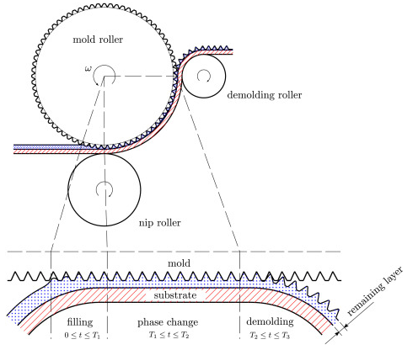~~

~~from the following article~~

[~~https://www.sciencedirect.com/science/article/pii/S2666496820300017~~](https://www.sciencedirect.com/science/article/pii/S2666496820300017)

~~in your publication~~

~~If we look carefully we can see that this article is published under a Creative Commons BY licence. This means that you may freely use the content (which includes publishing images from the article) as long as you reference the authors and publication.~~

~~How about if you wanted to include this image:~~

~~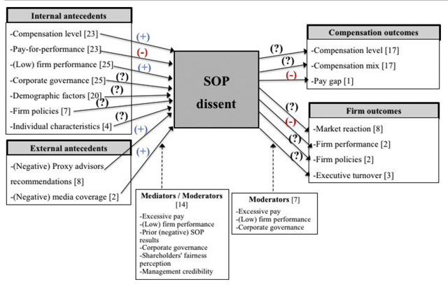~~

~~from this article:~~

[~~https://www-sciencedirect-com.libraryproxy.griffith.edu.au/science/article/pii/S1053482218305485~~](https://www-sciencedirect-com.libraryproxy.griffith.edu.au/science/article/pii/S1053482218305485)

~~This article doesn’t have a creative commons licence. To get permission or pay a licence to use this image, we then to to a “Get Rights” or “Get Permissions” link near the article. Here there is a “Get rights and content” link. This link takes us through to RightsLink which is a company that arranges permissions and licences for many publishers. Let’s image that I am a PHD student or Griffith academic wanting to include this image in an article I intend to publish. I need to fill out the pull down boxes. Sometimes the choice seems clunky, but simply choose the option that best applies.~~

~~I would like to reuse: In a journal or magazine~~

~~I am a: Academic/Educational institute~~

~~The intended publisher of the new work is: Lets say it’s: Springer Nature~~

~~I would like to use: Figures/Tables/illustrations~~

~~My number of Figures/Tables/illustrations: 1~~

~~My format is. Let’s imagine I will publish in an online journal: Electronic.~~

~~I am the author of this Elsevier journal: No.~~

~~I will be translating: No.~~

~~My currency is: Aus $~~

~~Quick price: No cost. It says: This reuse request is free of charge although you are required to obtain a license through Rightslink and, click the Continue button below. It takes about 5 minutes to get a licence.~~

~~A couple of things to note here.~~

~~If you were adapting an image and need permission to publish, there is no option here to adapt. So simply fill in the pull down boxes as if you were using the full image.~~

~~Secondly, let’s imagine that I was publishing my journal with a publisher not listed in this pull down box, the cost would be: $45.09. In fact it can sometimes cost you hundreds of dollars to publish an image.~~

~~It’s smart to check the STM Permissions Guidelines before asking permission from a publisher to use an image from a book or journal. When seeking permission not all publishers will remind you they are listed on these guidelines and you can save yourself paying licence fees.~~

~~To check the STM Permissions Guidelines google: “STM Permissions Guidelines”.~~

~~You will see here a long list of publishers including Elsevier. These publishers have a reciprocal agreement with each other permitting their authors to include images or figures from each other’s publications without charge. So if both your publisher and the publisher of the image are on this list, there is no cost to use the image. It also saves you the trouble of getting permission through RightsLink. Though sometimes you are required to notify a publisher you are using their image.~~

What if you need written permission or need to pay a licence fee to include an image? Is there any other alternative? Well if you are directly subjecting images to “Criticism or Review” in your publications you may be able to include them. If you are including an image as an example or to build an argument, the Criticism or Review exception would not apply. But if you are actively and critiquing or analysing an image, then you can build an argument for including the image under the Criticism or Review exception. The threshold for including an image under the Criticism or Review exception in your thesis for publication by Griffith would be much lower than for example including in a journal article. To include in a journal article, your criticism or review would need to be substantial. Best to contact me if you have any questions particularly if you wish to use the Criticism or Review exception to include a figure or image in a journal article or book chapter.

Linking to material. If you write in an online journal or for an online newspaper such as The Conversation, you may sometimes want to link to webpages or videos. It is OK to do this. This is because by providing a link, you are simply pointing to where others may view a published resource. You yourself are not publishing the resource.

Using prosaic material. I’ve already outlined that when publishing images and figures you source, you need the copyright rights to publish, for example through a Creative Commons licence or through written permission from the copyright owner. This would apply to the image of the femur bone on the left of this slide. But what if you sourced the outline sketch of a femur bone on the right? I would argue that image is so common or basic, there is no copyright protection. There is not sufficient substance or originality in the image for it to attract copyright protection.

A final consideration when sourcing images from the internet, is that some images such as this engineering mistake are spread across the internet where no attribution or copyright owner can be found. In this instance, where no owner has asserted themselves, in my view, it would not be unreasonable to publish this image.

**What if you adapt an image or diagram, and wish to publish your adaptation? Do you need permission or a licence from the copyright owner of the original? This will depend on whether your work contains a substantial amount of the original work. Have you copied an important, essential or distinctive part?**

**The answer to this question will depend on the circumstances in each case. It also can depend on the medium. For example, the substantiality threshold in music is very low. Even part of a bar of music or an underlying drum beat can be considered substantial. Every couple of months there is yet another musician who is taken to Court for taking a substantial amount of another musician’s song without permission or a licence. The copying may be less than half a dozen notes, and the payout is often hundreds or millions of dollars.**

**Let’s imagine someone adapted the image on the left here and created the image on the right. Would they need permission to publish their adapted image? In my view, without doubt, as they have copied a distinctive part of the design. Feel free to contact me if you would like assistance with the substantiality issue.**

So before you publish an image or another part of a copyright work, make sure you check to see if you need permission.

**To get permission, find out who the copyright owner is and adapt and send them one of the standard permissions emails on the Copyright website. If they are slow to respond, send a polite reminder a week or two later. If you have any issues, feel free to contact me.**